

A Project Report On

**Online Shopping**

**By**

**Manjushree R T**

**B.E**

**Batch:** 2021 – 5761

**Center: Banglore - Palya**

Under the Guidance of,

**Jayant V.**

**Technical Trainer**

**EduBridge**

(School of coding)

## Introduction:

Our project explains about the Online Shopping Website. This project mainly explains the various actions related to shop online. You can search various products and shuffle according to category. Our Project Include **Modules:-**

* Admin Module
* User Module

I have developed this Application in **Spring Boot, Maven, JSP/ Hibernate and MySQL.** It’s a web-based projects so I have used **HTML, CSS, JavaScript and Bootstrap also**.

The main feature of the project is to make shopping easier. You can access this website from anywhere and everywhere.

In Admin module, admin can add the Products in the specific category. He can also view the total number of users at present in the website. And category and product details also. Admin can only add products and whenever admin wants to edit can edit and delete the products .

In User module, New user can register and login after that to shop and can access the website and buy products by filling the payment form. And user can see reviews and about them. If user want can contact them by sending messages.

**Software Requirements:**

**Front end:** Java technologies (JSP), HTML, CSS, JavaScript, Bootstrap.

**Back end**: MySQL workbench 8.0.23CE, Hibernate.

**Middleware/Server:** Apache Tomcat v8.5. IDE: Eclipse IDE for Java EE Developers

**Browser:** Best result on Google Chrome

**Operating System:** Window 10

**Data Dictionary:**

**MySQL**

* Create Database OnlineShopping;
* Set : database.driver=com.mysql.jdbc.Driver

database.url=jdbc:mysql://localhost:3306/OnlineShopping

database.user=root

database.password=root123

**Hibernate**

* Set : hibernate.dialect=org.hibernate.dialect.MySQLDialect

hibernate.show_sql=true

hibernate.format_sql=true

hibernate.hbm2ddl.auto=update

* Map Tables;

hibernate.mapping_class=Register

hibernate.mapping_class=Contact

hibernate.mapping_class=Payment

hibernate.mapping_class=Product

* Create Tables using this Annotations.

@Id

@Column

@Table

@GeneratedValue

# Screenshots:

## Home Page:

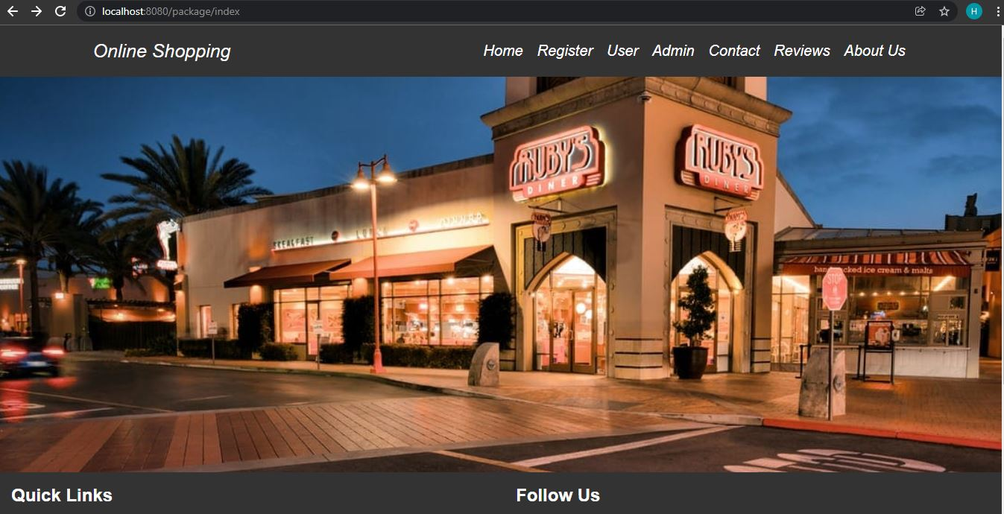

**Fig** : Home Page – In this page can see quick links in footer and can see navigation bar in header part in navigation bar some hyper links is there by clicking on that I can go to perticular page.

**Registration Page:**

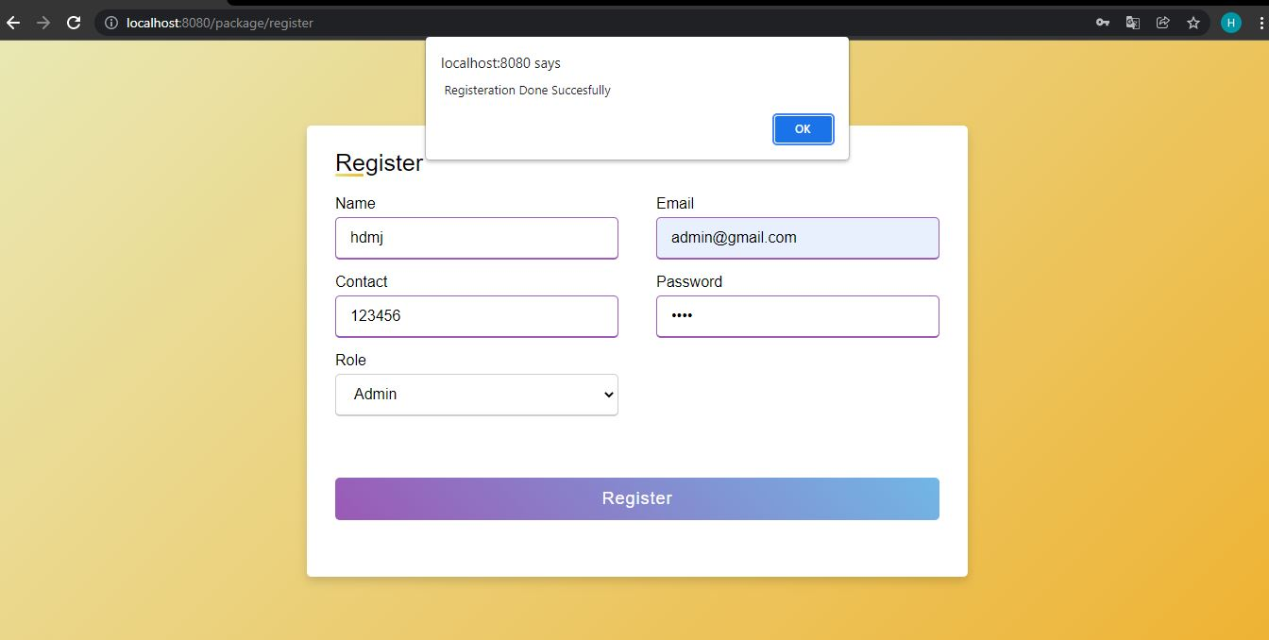

**Fig** : Registration Page – In this page user can register their self by filling details. After filling the form user will get alert message that “Registration done Succesfully”.

**Reviews Page:**

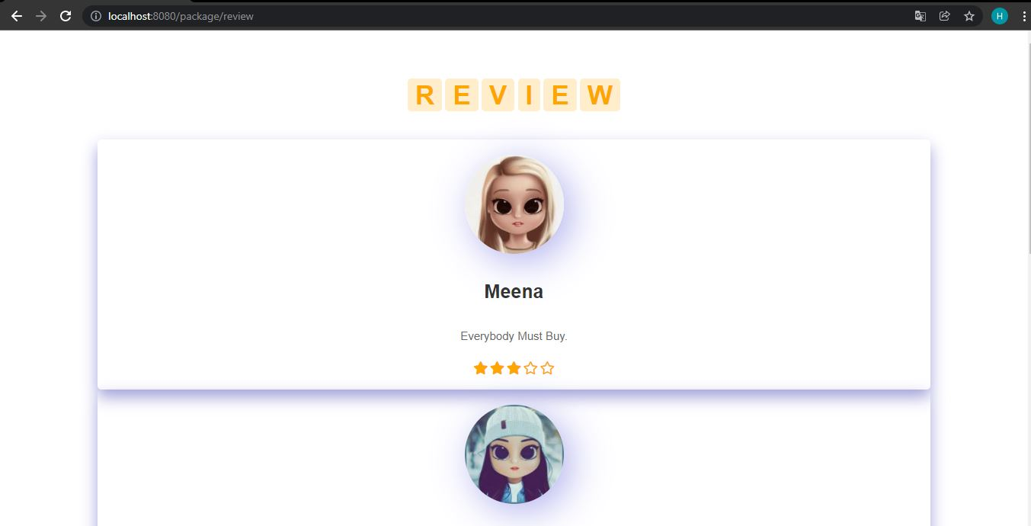

**Fig** : Reviews Page – In this page users can reviews of other existing users.

**Contact Us Page:**

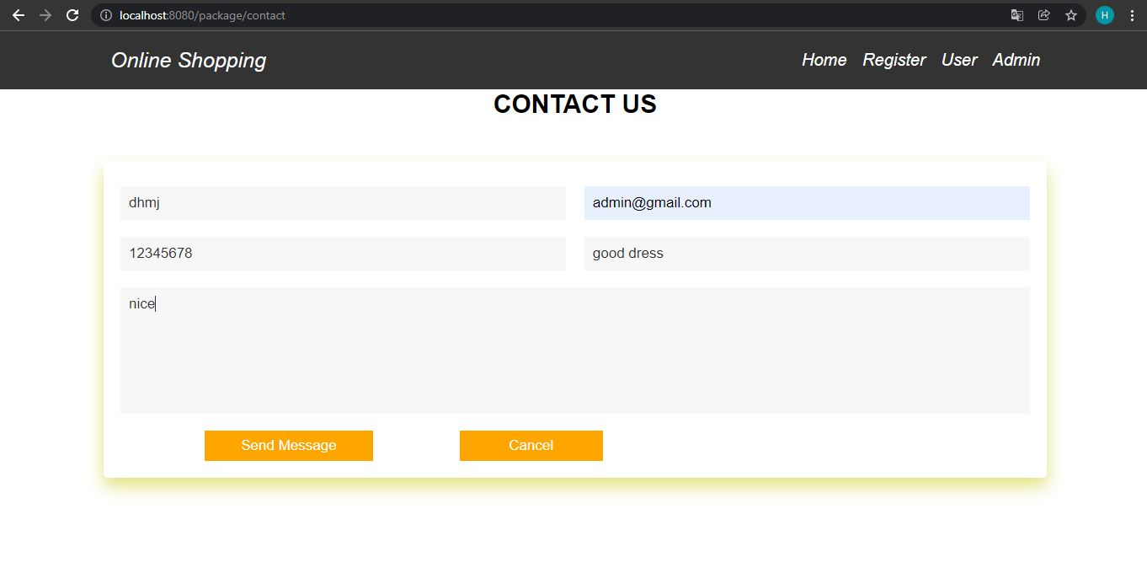

**Fig** : Contact Page : In this page users if wants to contact they can contact y filling details.

**Admin Page :**

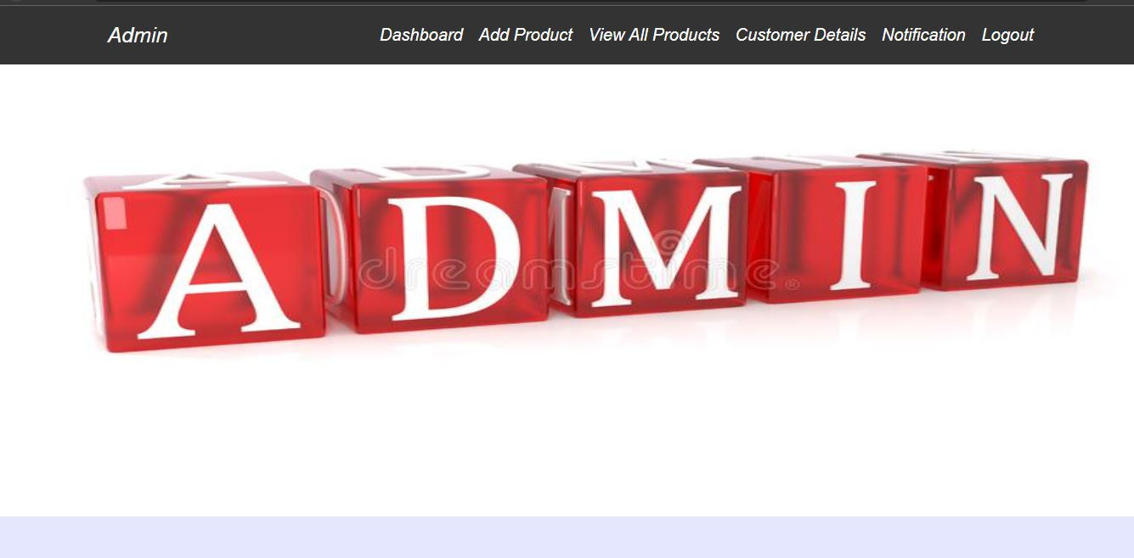

**Fig** : Admin Page – This page is admin dashboard page. Here user can add products, view customer details and customers messages by clicking hyperlinks which is in navigation bar.

**Admin Add Products Page:**

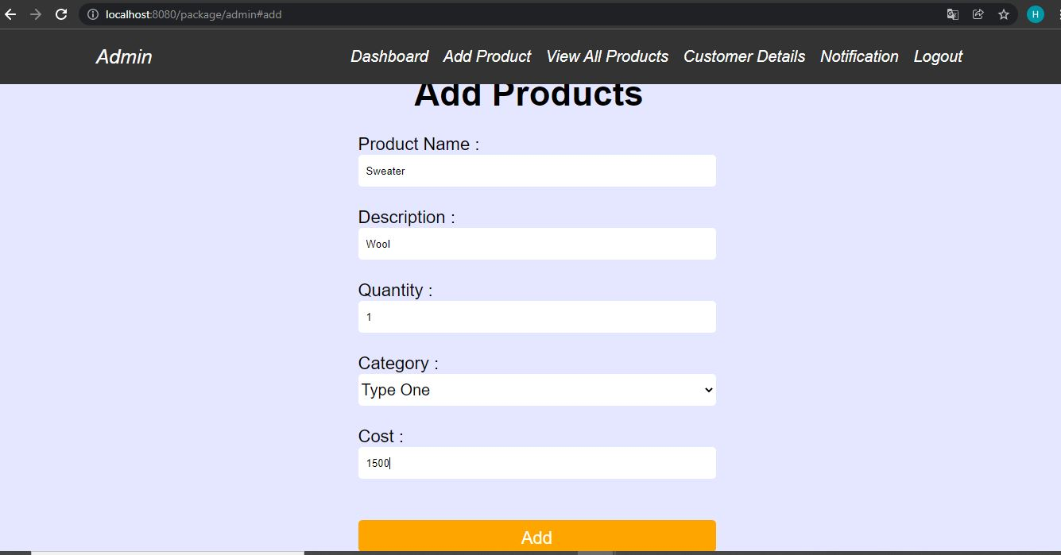

**Fig** : Admin Add Products Page : In this page admin can add the products by filling the form.

**Admin Update Products Page :**

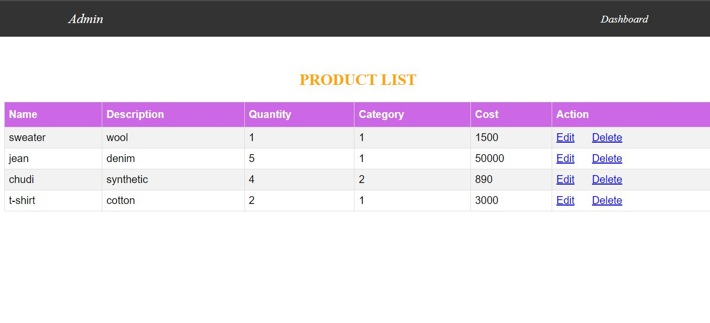

**Fig** : Admin Update Products Page – In this page admin can edit the products and delete the products whichever want.

**Notification Page:**

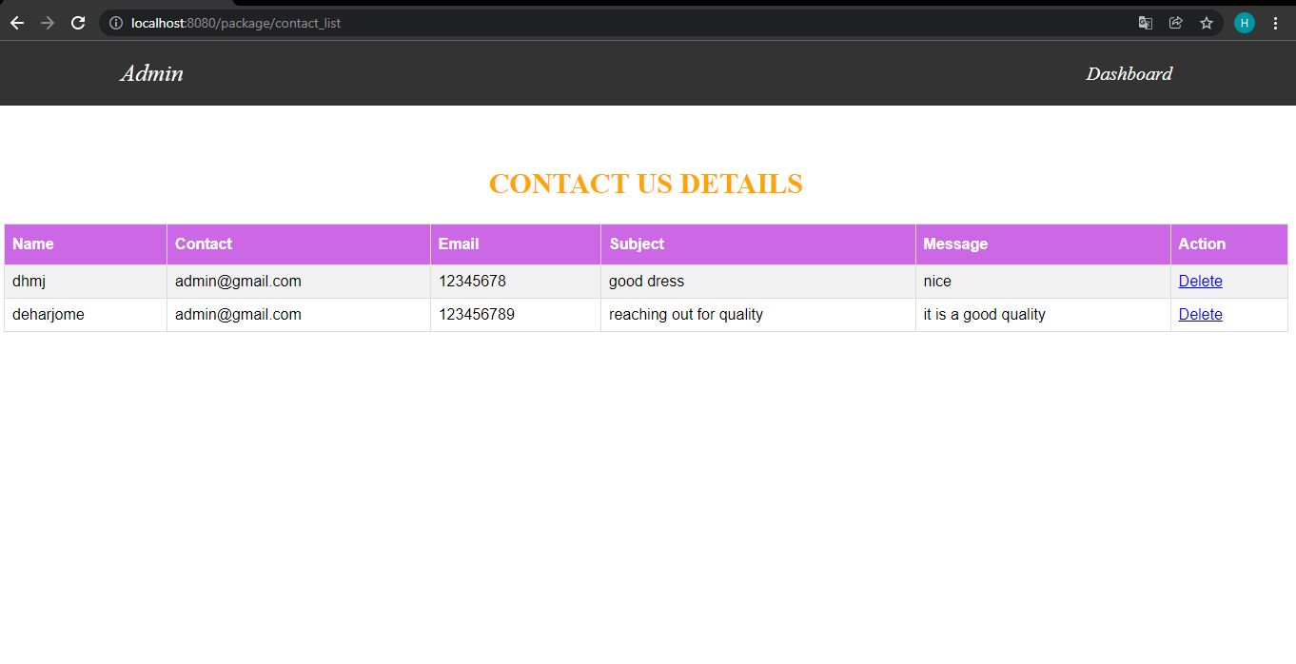

**Fig** : Notification Page – In this page admin can see customers messages after reading can delete that message.

**Customer Details Page :**

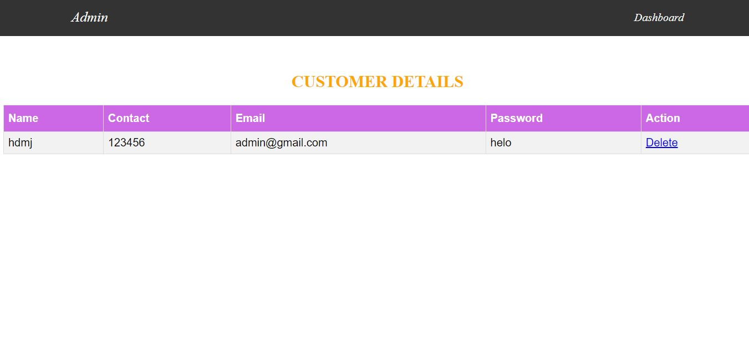

**Fig** : Customer Details Page – In this page admin can view the registered users.

**User Page :**

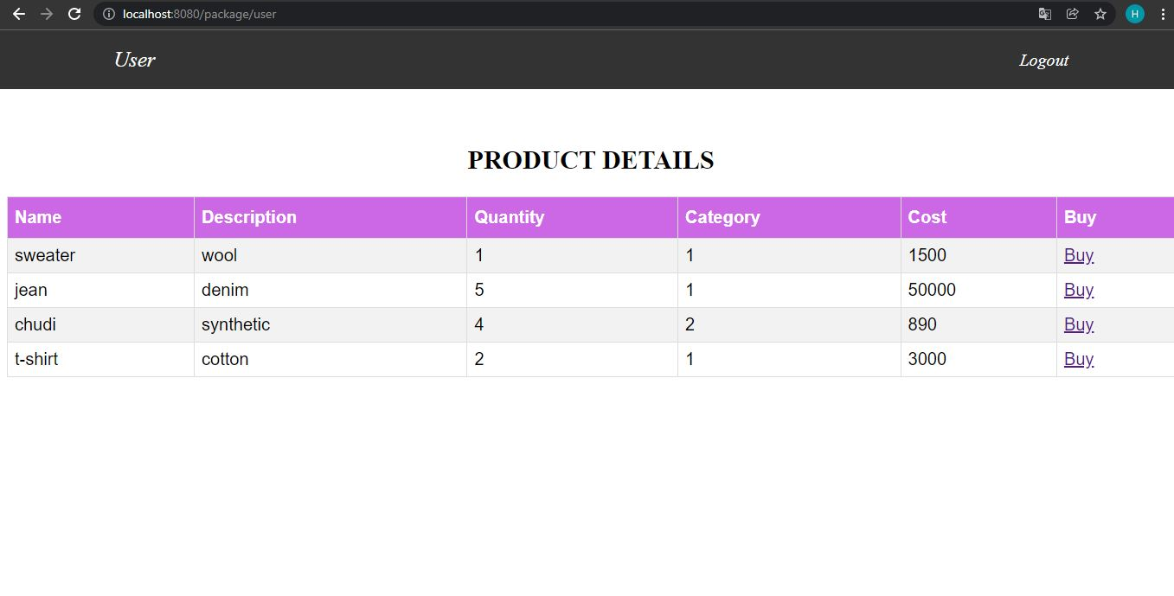

**Fig** : User Page – In this page user can view the products and whichever want user can buy that products.

**Payment Page :**

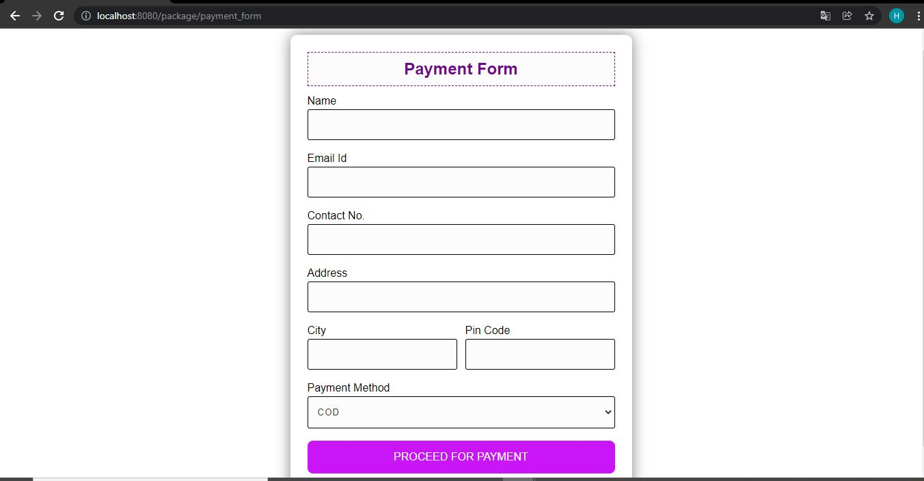

**Fig** : Payment page – In this page user can finish their payment method by filling this form.

**Thank you**